**Come Feel The Spirit At Our**

**2015 Lenten Retreat**

**with**

**Dr. Jayanand**

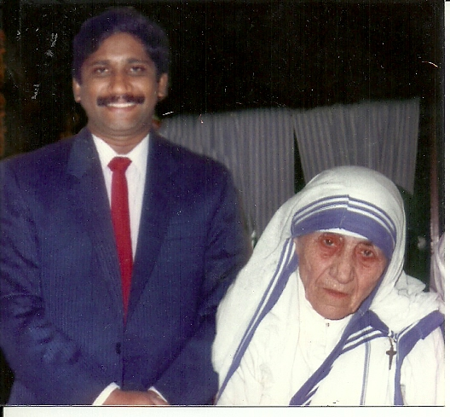

***Renowned Catholic Evangelist, Dr. Jayanand, is a dynamic inspirational speaker who has been preaching the gospel to tens of thousands***

***of the faithful throughout the world for more than 35 years.***

**Saturday, Feb. 28, 2015**

**From 9.30 AM and ends with Vigil Mass at 4.00 PM**

**(Lunch break at 12.00 noon)**

**Talk & Healing Service**

**St. Joseph Parish**

**173 Albion Street, Wakefield, MA 01880**

**(781) 245-5770 or (781) 534-5654**

**Please register at** [**http://goo.gl/forms/Z0irPNkFtP**](http://goo.gl/forms/Z0irPNkFtP)